Prevalence of chronic kidney disease among adults on antiretroviral therapy in northern Namibia: a cross-sectional study

Michael Mboko¹, Tonya Marianne Esterhuizen¹, Mogamat Razeen Davids²

¹Division of Epidemiology and Biostatistics, Stellenbosch University, Cape Town, South Africa; ²Division of Nephrology, Stellenbosch University and Tygerberg Hospital, Cape Town, South Africa.

Article type: Original article

Running title: CKD in HIV-infected Namibian patients

Word count: 3 250

Received 10 January 2026; accepted 27 April 2026; published xx May 2026.
Correspondence: Razeen Davids, mrd@sun.ac.za.
© The Author(s) 2026. Published under a Creative Commons Attribution 4.0 International License.
DOI: https://doi.org/10.21804/29-1-9900.

Abstract

Introduction: Lorem ipsum dolor sit amet, consectetur adipiscing elit. Sed do eiusmod tempor incididunt ut labore et dolore magna aliqua. The burden of chronic kidney disease (CKD) in low- and middle-income countries (LMICs) is rising, with prevalence estimates ranging from 4.8–13.9% [1-3]. Published data on the prevalence of CKD in this population are scarce.

Methods: We conducted a cross-sectional study using existing electronic records. We estimated the glomerular filtration rate (GFR) using the CKD-EPI equation. CKD was defined as estimated GFR (eGFR) < 60 mL/min/1.73 m² on two occasions at least three months apart. Factors associated with CKD were assessed using logistic regression.

Results: We included 1 993 participants, of whom 1 362 (68%) were female, with a mean age of 44.5 ± 11.5 years. The prevalence of CKD was 1.4% (95% CI 1.0–2.0%). CKD cases were significantly more likely to be older than 45 years (OR 13.2; 95% CI 4.1–42.5; P < 0.001) and male (OR 3.5; 95% CI 1.4–8.7; P = 0.006).

Conclusions: Our findings suggest a low prevalence of CKD among this population. Patients older than 45 years may need additional monitoring of kidney function.

Keywords: chronic kidney disease; HIV; eGFR; Namibia; sub-Saharan Africa.

Introduction

Chronic kidney disease (CKD) is a condition characterised by abnormalities of kidney function or kidney structure that have been present for at least three months, with implications for health [1]. Lorem ipsum dolor sit amet, consectetur adipiscing elit, sed do eiusmod tempor incididunt ut labore et dolore magna aliqua [2,3].

An eGFR of less than 60 mL/min/1.73 m² for at least three months is used as the threshold to diagnose CKD [1]. Ut enim ad minim veniam, quis nostrud exercitation ullamco laboris nisi ut aliquip ex ea commodo consequat. The prevalence of CKD in sub-Saharan Africa has been estimated at 4.8–13.9% [4-6], with higher rates in at-risk populations including those with hypertension, diabetes and HIV [6].

Duis aute irure dolor in reprehenderit in voluptate velit esse cillum dolore eu fugiat nulla pariatur. Excepteur sint occaecat cupidatat non proident, sunt in culpa qui officia deserunt mollit anim id est laborum. Martins et al. [7] found that early detection and treatment of CKD can slow disease progression.

In this study, we aimed to estimate the prevalence of CKD and associated factors in adults on antiretroviral therapy in northern Namibia.

Methods

Study design
We conducted a cross-sectional study in the four regions of northern Namibia, using existing electronic records. Lorem ipsum dolor sit amet, consectetur adipiscing elit. We used standardised serum creatinine measurements to estimate the GFR using the CKD-EPI equation. Blood pressure was recorded in mmHg. …

Data analysis
Data were analysed using Stata version 16.1 (StataCorp, College Station, TX). Continuous variables were summarised as mean ± standard deviation (SD) or median and interquartile range (IQR), as appropriate. Categorical variables were expressed as frequencies and percentages. Logistic regression was used to assess factors associated with CKD. A P value of < 0.05 was considered statistically significant.

Ethical approval
Approval to conduct this study was granted by the Health Research Ethics Committee (HREC) of the University of Stellenbosch (reference number S20/01/001). All participants provided written informed consent.

Results

A total of 1 993 participants were included. The characteristics of the study population are summarised in Table 1. The mean age was 44.5 ± 11.5 years and 1 362 (68%) were female. The median duration on antiretroviral therapy was 107 months (IQR 62–149).

The prevalence of CKD was 1.4% (95% CI 1.0–2.0%). In multivariable logistic regression, age ≥ 45 years (OR 13.2; 95% CI 4.1–42.5; P < 0.001) and male sex (OR 3.5; 95% CI 1.4–8.7; P = 0.006) were independently associated with CKD (see Figure 1).

Table 1. Characteristics of participants.
 | N | Female, n (%) | Male, n (%) | Age (years) mean ± SD | ART duration (months) median (IQR) | TDF use, % (95% CI)
Overall | 1 993 | 1 362 (68) | 631 (32) | 44.5 ± 11.5 | 107 (62–149) | 94 (93–95)

Abbreviations: ART, antiretroviral therapy; CI, confidence interval; IQR, interquartile range; SD, standard deviation; TDF, tenofovir disoproxil fumarate.

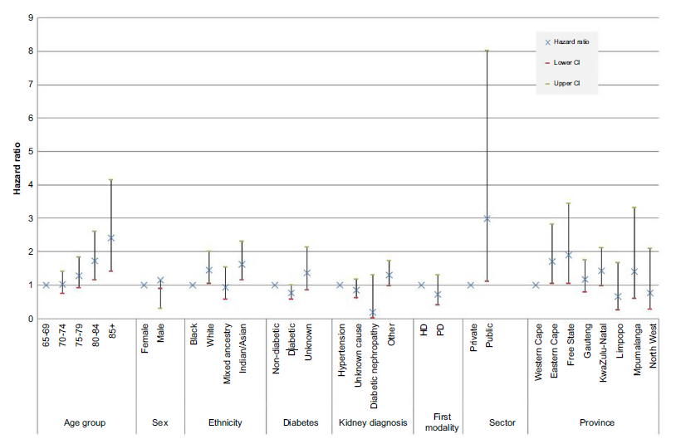

Figure 1. Hazard ratios by multivariable Cox regression for each of the potential risk factors for 1-year survival. Error bars represent 95% confidence intervals.

Discussion

The prevalence of CKD in this study of adults on antiretroviral therapy in northern Namibia was 1.4%. Lorem ipsum dolor sit amet, consectetur adipiscing elit, sed do eiusmod tempor incididunt ut labore et dolore magna aliqua. Ut enim ad minim veniam, quis nostrud exercitation ullamco laboris.

Duis aute irure dolor in reprehenderit in voluptate velit esse cillum dolore eu fugiat nulla pariatur. Excepteur sint occaecat cupidatat non proident, sunt in culpa qui officia deserunt mollit anim id est laborum [8-10].

Strengths and Limitations
Lorem ipsum dolor sit amet, consectetur adipiscing elit. A strength of this study is that we used two eGFR measurements at least three months apart to define CKD, in keeping with international guidelines [1]. The main limitation was the cross-sectional design—causality cannot be inferred from these data.

Conclusions

Our findings suggest a low prevalence of CKD among adults on antiretroviral therapy in northern Namibia. Patients older than 45 years may need additional monitoring of kidney function using eGFR.

Acknowledgements
The authors acknowledge the hospital authorities, data clerks and NIP staff for their assistance and cooperation during the data collection process. Funding for the study was provided by the University of Stellenbosch.

Conflicts of interest
MRD is deputy editor of the AJN. The other authors have no conflicts of interest to declare.

Use of AI in manuscript preparation
No AI tools were used in the preparation of this manuscript.

References

- Kidney Disease: Improving Global Outcomes (KDIGO) CKD Work Group. KDIGO 2012 clinical practice guideline for the evaluation and management of chronic kidney disease. Kidney Int Suppl. 2013; 3:1-150.
- Xie Y, Bowe B, Mokdad AH, Xian H, Yan Y, Li T, et al. Analysis of the Global Burden of Disease study highlights the global, regional, and national trends of chronic kidney disease epidemiology from 1990 to 2016. Kidney Int. 2018; 94(3):567-581.
- Stanifer JW, Jing B, Tolan S, Helmke N, Mukerjee R, Naicker S, et al. The epidemiology of chronic kidney disease in sub-Saharan Africa: a systematic review and meta-analysis. Lancet Glob Health. 2014; 2(3):e174-e181.
- Halperin ML, Goldstein MB, Kamel KS. Fluid, electrolyte, and acid-base physiology: a problem-based approach. Philadelphia, PA: Saunders; 2010.
- Topham PS, Chen Y. Renal biopsy. In: Floege J, Johnson RJ, Feehally J, editors. Comprehensive clinical nephrology. 4th ed. Philadelphia, PA: Saunders; 2010. pp. 75-84.
- Kaze AD, Ilori T, Jaar BG, Echouffo-Tcheugui JB. Burden of chronic kidney disease on the African continent: a systematic review and meta-analysis. BMC Nephrol. 2018; 19(1):125.
- Martins MC, Meyers AM, Whalley NA, Margolius LP, Buys ME. Indapamide (Natrilix): the agent of choice in the treatment of recurrent renal calculi associated with idiopathic hypercalciuria. Br J Urol. 1996; 78:176-180.
- Ghana AIDS Commission. National and sub-national HIV and AIDS estimates and projections. Available from: www.ghanaids.gov.gh. Accessed 17 June 2021.
- Lorem IP, Dolor SA, Amet CE, Consectetur AD, Elit SE, Tempor ID, et al. Eiusmod incididunt ut labore et dolore magna aliqua ut enim. Nephrol Dial Transplant. 2022; 37:424-431.
- Ipsum LD, Sit AQ. Dolor amet consectetur adipiscing elit sed do. Kidney Int. 2021; 99:988-994.

